**INTRODUCTION**

**AIM OF THE PROJECT:**

Regular servicing is very important for keeping your vehicle in good driving condition. It is recommended to regularly visit a car service centre for detailed car inspections. Servicing your vehicle is very important, especially if you use your vehicle extensively. Yes, by servicing your vehicle on a regular basis, you will avoid costly repairs and will save lot of money. Here’s what you need to pay attention to. Garage service is a most commonly known activity in almost all urban areas where all types of motor vehicles like cars & bike are periodically sent for repairing and servicing. Improper maintenance of vehicles, present conditions of roads, irresponsible driving, using cheaper spare parts etc are the main reasons for break-down of the vehicles. Service station is the most essential unit to vehicle users. This unit can be established in urban, semi-urban and village areas to meet the local requirement. Candidates having good experience

**ABOUT THE PROJECT**

The Customer should be able to sign up and login into the application using the ID created. Without a login ID, customer can only search for offers and about the application. This includes high-level design, UI screens development, data storage, and manipulation and business logic using the concepts of core and advanced Java. A running website hosted locally or remotely (on a cloud), the design document created and the source code used in a zip file. Idea behind the system is to provide as much as service to the owner of the service centre as possible.

Here we are trying to manage different entity. Owner of the service centre, Mechanic who is there to repair specific car and bike, user or vehicle owner which is taking the service. At first user has to make account by providing phone number and creating a password. User’s personal data will be encrypted and secured. Now all of the queries of the user will be handled by the system we are going to provide. In user login customer can use the map according to location using latitude and longitude where it is much user friendly for the customer to track garage nearby. Here we offer the deals for only the customer who are register in the our web application. In business login section the garage owner or mechanic need to register to show the customer of their garage location and details of owner or mechanic. After registeration, freelisting page display to garagers there need to provide the contact details, company name, need to select which service there are going to provide car or bike, select the location where there garage is available and need to select the state and country. Customer can take phone number of garage owner or mechanic and book appointment of car or bike. This project is to create a web-based application using Java and HTML for an online garages that includes the customers to search for garages and check for offers available. Online garages System is an website that allows a customer to search for nearest various garages available at the store, segregate according to the location , Unique data of garages available and offers available at the garage



***LITERATURE SURVEY***

Literature [survey](http://www.blurtit.com/q876299.html) is the most important step in software development process. Before developing the tool it is necessary to determine the time factor, economy and company strength. Once these things are satisfied, ten next steps are to determine which operating system and language can be used for developing the tool. Once the [programmers](http://www.blurtit.com/q876299.html) start building the tool the programmers need lot of support. This support can be obtained from senior programmers,from [book](http://www.blurtit.com/q876299.html) or from websites. Before building the system the above consideration r taken into account for developing the proposed system.

**EXISTING SYSTEM**

* The Existing system is manual system.
* All kind of works are carried out manually by customers
* Its been difficult in emergency situations to search for a mechanic or workshop in remote

**PROPOSED SYSTEM:**

* The proposed system is online based web application.
* “ E-Workshop ” is to easily track the information of workshops nearby our location.
* It reduces the burden of customers.
* This E-WORKSHOP is very much useful in emergency purpose for public.if they stuck in a spot while travelling from one place to another its difficult to find a workshop nearby our current location in that time e-workshop helps to display the details of workshops nearby location using your location lattitude and longitude.

***SYSTEM ANALYSIS***

***FEASIBILITY STUDY:***

The feasibility of the project is analyzed in this phase and business proposal is put forth with a very general plan for the project and some cost estimates. During system analysis the feasibility study of the proposed system is to be carried out. This is to ensure that the proposed system is not a burden to the company. For feasibility analysis, some understanding of the major requirements for the system is essential.

Three key considerations involved in the feasibility analysis are

* ECONOMICAL FEASIBILITY
* TECHNICAL FEASIBILITY
* SOCIAL FEASIBILITY

**ECONOMICAL FEASIBILITY:**

This study is carried out to check the economic impact that the system will have on the organization. The amount of fund that the company can pour into the research and development of the system is limited. The expenditures must be justified. Thus the developed system as well within the budget and this was achieved because most of the technologies used are freely available. Only the customized products had to be purchased.

**TECHNICAL FEASIBILITY:**

This study is carried out to check the technical feasibility, that is, the technical requirements of the system. Any system developed must not have a high demand on the available technical resources. This will lead to high demands on the available technical resources. This will lead to high demands being placed on the client. The developed system must have a modest requirement, as only minimal or null changes are required for implementing this system

**SOCIAL FEASIBILITY:**

The aspect of study is to check the level of acceptance of the system by the user. This includes the process of training the user to use the system efficiently. The user must not feel threatened by the system, instead must accept it as a necessity. The level of acceptance by the users solely depends on the methods that are employed to educate the user about the system and to make him familiar with it. His level of confidence must be raised so that he is also able to make some constructive criticism, which is welcomed, as he is the final user of the system.

**HARDWARE AND SOFTWARE REQUIREMENTS**

**SOFTWARE REQUIREMENTS:**

Software the system that is used in this project is,

Operating System:            WINDOWS 7

Front end:                          JSP

Back end:                          SQL SERVER

**MINIMUM HARDWARE REQUIREMENTS:**

Hardware specification of the system that is used in this project is,

° Processor Intel® Core®(1.86 GHZ)

° Memory 1 GB RAM

° Hard disk 250 GB

## *Java Technology*

Java technology is both a programming language and a platform.

### The Java Programming Language

### The Java programming language is a high-level language that can be characterized by all of the following buzzwords:

* + - Simple
    - Architecture neutral
    - Object oriented
    - Portable
    - Distributed
    - High performance
    - Interpreted
    - Multithreaded
    - Robust
    - Dynamic
    - Secure

With most programming languages, you either compile or interpret a program so that you can run it on your computer. The Java programming language is unusual in that a program is both compiled and interpreted. With the compiler, first you translate a program into an intermediate language called Java byte codes —the platform-independent codes interpreted by the interpreter on the Java platform. The interpreter parses and runs each Java byte code instruction on the computer. Compilation happens just once; interpretation occurs each time the program is executed. The following figure illustrates how this works.

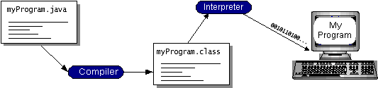

You can think of Java byte codes as the machine code instructions for the Java Virtual Machine (Java VM). Every Java interpreter, whether it’s a development tool or a Web browser that can run applets, is an implementation of the Java VM. Java byte codes help make “write once, run anywhere” possible. You can compile your program into byte codes on any platform that has a Java compiler. The byte codes can then be run on any implementation of the Java VM. That means that as long as a computer has a Java VM, the same program written in the Java programming language can run on Windows 2000, a Solaris workstation, or on an iMac.

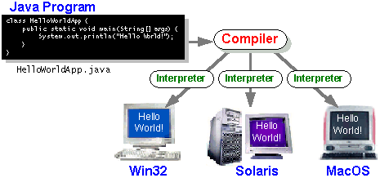

### The Java Platform

A platform is the hardware or software environment in which a program runs. We’ve already mentioned some of the most popular platforms like Windows 2000, Linux, Solaris, and MacOS. Most platforms can be described as a combination of the operating system and hardware. The Java platform differs from most other platforms in that it’s a software-only platform that runs on top of other hardware-based platforms.

The Java platform has two components:

* The Java Virtual Machine (Java VM)
* The Java Application Programming Interface (Java API)

You’ve already been introduced to the Java VM. It’s the base for the Java platform and is ported onto various hardware-based platforms.

The Java API is a large collection of ready-made software components that provide many useful capabilities, such as graphical user interface (GUI) widgets. The Java API is grouped into libraries of related classes and interfaces; these libraries are known as packages. The next section, What Can Java Technology Do? Highlights what functionality some of the packages in the Java API provide.

The following figure depicts a program that’s running on the Java platform. As the figure shows, the Java API and the virtual machine insulate the program from the hardware.

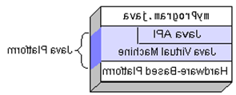

Native code is code that after you compile it, the compiled code runs on a specific hardware platform. As a platform-independent environment, the Java platform can be a bit slower than native code. However, smart compilers, well-tuned interpreters, and just-in-time byte code compilers can bring performance close to that of native code without threatening portability.

## What Can Java Technology Do?

The most common types of programs written in the Java programming language are applets and applications. If you’ve surfed the Web, you’re probably already familiar with applets. An applet is a program that adheres to certain conventions that allow it to run within a Java-enabled browser.

However, the Java programming language is not just for writing cute, entertaining applets for the Web. The general-purpose, high-level Java programming language is also a powerful software platform. Using the generous API, you can write many types of program

An application is a standalone program that runs directly on the Java platform. A special kind of application known as a server serves and supports clients on a network. Examples of servers are Web servers, proxy servers, mail servers, and print servers. Java Servlets are a popular choice for building interactive web applications, replacing the use of CGI scripts

How does the API support all these kinds of programs? It does so with packages of software components that provides a wide range of functionality. Every full implementation of the Java platform gives you the following features:

* **The essentials**: Objects, strings, threads, numbers, input and output, data structures, system properties, date and time, and so on.
* **Applets**: The set of conventions used by applets
* **Networking**: URLs, TCP (Transmission Control Protocol), UDP (User Data gram Protocol) sockets, and IP (Internet Protocol) addresses.
* **Internationalization**: Help for writing programs that can be localized for users worldwide. Programs can automatically adapt to specific locales and be displayed in the appropriate language.
* **Security**: Both low level and high level, including electronic signatures, public and private key management, access control, and certificates.
* **Software components**: Known as JavaBeansTM, can plug into existing component architectures.
* **Object serialization**: Allows lightweight persistence and communication via Remote Method Invocation (RMI).
* **Java Database Connectivity (JDBCTM)**: Provides uniform access to a wide range of relational databases.

The Java platform also has APIs for 2D and 3D graphics, accessibility, servers, collaboration, telephony, speech, animation, and more. The following figure depicts what is included in the Java 2 SDK.

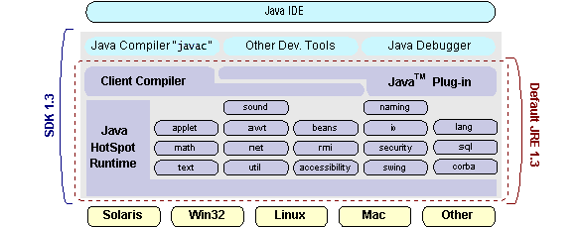

## How Will Java Technology Change My Life?

We can’t promise you fame, fortune, or even a job if you learn the Java programming language. Still, it is likely to make your programs better and requires less effort than other languages. We believe that Java technology will help you do the following:

* **Get started quickly**: Although the Java programming language is a powerful object-oriented language, it’s easy to learn, especially for programmers already familiar with C or C++.
* **Write less code**: Comparisons of program metrics (class counts, method counts, and so on) suggest that a program written in the Java programming language can be four times smaller than the same program in C++.
* **Write better code**: The Java programming language encourages good coding practices, and its garbage collection helps you avoid memory leaks. Its object orientation, its JavaBeans component architecture, and its wide-ranging, easily extendible API let you reuse other people’s tested code and introduce fewer bugs.
* **Develop programs more quickly**: Your development time may be as much as twice as fast versus writing the same program in C++. Why? You write fewer lines of code and it is a simpler programming language than C++.
* **Avoid platform dependencies with 100% Pure Java**: You can keep your program portable by avoiding the use of libraries written in other languages. The 100% Pure JavaTM Product Certification Program has a repository of historical process manuals, white papers, brochures, and similar materials online.
* **Write once, run anywhere**: Because 100% Pure Java programs are compiled into machine-independent byte codes, they run consistently on any Java platform.
* **Distribute software more easily**: You can upgrade applets easily from a central server. Applets take advantage of the feature of allowing new classes to be loaded “on the fly,” without recompiling the entire program.

### *ODBC :*

Microsoft Open Database Connectivity (ODBC) is a standard programming interface for application developers and database systems providers. Before ODBC became a *de facto* standard for Windows programs to interface with database systems, programmers had to use proprietary languages for each database they wanted to connect to. Now, ODBC has made the choice of the database system almost irrelevant from a coding perspective, which is as it should be. Application developers have much more important things to worry about than the syntax that is needed to port their program from one database to another when business needs suddenly change.

Through the ODBC Administrator in Control Panel, you can specify the particular database that is associated with a data source that an ODBC application program is written to use. Think of an ODBC data source as a door with a name on it. Each door will lead you to a particular database. For example, the data source named Sales Figures might be a SQL Server database, whereas the Accounts Payable data source could refer to an Access database. The physical database referred to by a data source can reside anywhere on the LAN.

The ODBC system files are not installed on your system by Windows 95. Rather, they are installed when you setup a separate database application, such as SQL Server Client or Visual Basic 4.0. When the ODBC icon is installed in Control Panel, it uses a file called ODBCINST.DLL. It is also possible to administer your ODBC data sources through a stand-alone program called ODBCADM.EXE. There is a 16-bit and a 32-bit version of this program and each maintains a separate list of ODBC data sources.

From a programming perspective, the beauty of ODBC is that the application can be written to use the same set of function calls to interface with any data source, regardless of the database vendor. The source code of the application doesn’t change whether it talks to Oracle or SQL Server. We only mention these two as an example. There are ODBC drivers available for several dozen popular database systems. Even Excel spreadsheets and plain text files can be turned into data sources.

The operating system uses the Registry information written by ODBC Administrator to determine which low-level ODBC drivers are needed to talk to the data source (such as the interface to Oracle or SQL Server). The loading of the ODBC drivers is transparent to the ODBC application program. In a client/server environment, the ODBC API even handles many of the network issues for the application programmer.

The advantages of this scheme are so numerous that you are probably thinking there must be some catch. The only disadvantage of ODBC is that it isn’t as efficient as talking directly to the native database interface. ODBC has had many detractors make the charge that it is too slow. Microsoft has always claimed that the critical factor in performance is the quality of the driver software that is used. In our humble opinion, this is true. The availability of good ODBC drivers has improved a great deal recently. And anyway, the criticism about performance is somewhat analogous to those who said that compilers would never match the speed of pure assembly language. Maybe not, but the compiler (or ODBC) gives you the opportunity to write cleaner programs, which means you finish sooner. Meanwhile, computers get faster every year.

***JDBC:***

In an effort to set an independent database standard API for Java; Sun Microsystems developed Java Database Connectivity, or JDBC. JDBC offers a generic SQL database access mechanism that provides a consistent interface to a variety of RDBMSs. This consistent interface is achieved through the use of “plug-in” database connectivity modules, or *drivers*. If a database vendor wishes to have JDBC support, he or she must provide the driver for each platform that the database and Java run on.

To gain a wider acceptance of JDBC, Sun based JDBC’s framework on ODBC. As you discovered earlier in this chapter, ODBC has widespread support on a variety of platforms. Basing JDBC on ODBC will allow vendors to bring JDBC drivers to market much faster than developing a completely new connectivity solution.

JDBC was announced in March of 1996. It was released for a 90 day public review that ended June 8, 1996. Because of user input, the final JDBC v1.0 specification was released soon after.

The remainder of this section will cover enough information about JDBC for you to know what it is about and how to use it effectively. This is by no means a complete overview of JDBC. That would fill an entire book.

### JDBC Goals:

Few software packages are designed without goals in mind. JDBC is one that, because of its many goals, drove the development of the API. These goals, in conjunction with early reviewer feedback, have finalized the JDBC class library into a solid framework for building database applications in Java.

The goals that were set for JDBC are important. They will give you some insight as to why certain classes and functionalities behave the way they do. The eight design goals for JDBC are as follows:

1. ***SQL Level API***

The designers felt that their main goal was to define a SQL interface for Java. Although not the lowest database interface level possible, it is at a low enough level for higher-level tools and APIs to be created. Conversely, it is at a high enough level for application programmers to use it confidently. Attaining this goal allows for future tool vendors to “generate” JDBC code and to hide many of JDBC’s complexities from the end user.

1. ***SQL Conformance***

SQL syntax varies as you move from database vendor to database vendor. In an effort to support a wide variety of vendors, JDBC will allow any query statement to be passed through it to the underlying database driver. This allows the connectivity module to handle non-standard functionality in a manner that is suitable for its users.

1. ***JDBC must be implemental on top of common database interfaces***

The JDBC SQL API must “sit” on top of other common SQL level APIs. This goal allows JDBC to use existing ODBC level drivers by the use of a software interface. This interface would translate JDBC calls to ODBC and vice versa.

1. ***Provide a Java interface that is consistent with the rest of the Java system***

Because of Java’s acceptance in the user community thus far, the designers feel that

they should not stray from the current design of the core Java system.

1. ***Keep it simple***

This goal probably appears in all software design goal listings. JDBC is no exception. Sun felt that the design of JDBC should be very simple, allowing for only one method of completing a task per mechanism. Allowing duplicate functionality only serves to confuse the users of the API.

1. ***Use strong, static typing wherever possible***

Strong typing allows for more error checking to be done at compile time; also, less error appear at runtime.

1. ***Keep the common cases simple***

Because more often than not, the usual SQL calls used by the programmer are simple SELECT’s, INSERT’s, DELETE’s and UPDATE’s, these queries should be simple to perform with JDBC. However, more complex SQL statements should also be possible

.

Finally we decided to proceed the implementation using Java Networking.

And for dynamically updating the cache table we go for MS Access database.

Java ha two things: a programming language and a platform.

Java is a high-level programming language that is all of the following

Simple Architecture-neutral

Object-oriented Portable

Distributed High-performance

Interpreted multithreaded

Robust Dynamic

Secure

Java is also unusual in that each Java program is both compiled and interpreted. With a compile you translate a Java program into an intermediate language called Java byte codes the platform-independent code instruction is passed and run on the computer.

Compilation happens just once; interpretation occurs each time the program is executed. The figure illustrates how this works.

**Java Program**

**Compilers**

**Interpreter**

**My Program**

You can think of Java byte codes as the machine code instructions for the Java Virtual Machine (Java VM). Every Java interpreter, whether it’s a Java development tool or a Web browser that can run Java applets, is an implementation of the Java VM. The Java VM can also be implemented in hardware.

Java byte codes help make “write once, run anywhere” possible. You can compile your Java program into byte codes on my platform that has a Java compiler. The byte codes can then be run any implementation of the Java VM. For example, the same Java program can run Windows NT, Solaris, and Macintosh.

## Networking:

### TCP/IP stack

The TCP/IP stack is shorter than the OSI one:

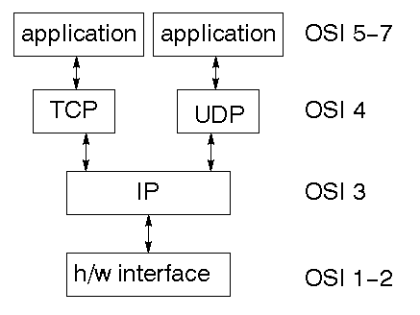

TCP is a connection-oriented protocol; UDP (User Datagram Protocol) is a connectionless protocol.

### IP datagram’s

The IP layer provides a connectionless and unreliable delivery system. It considers each datagram independently of the others. Any association between datagram must be supplied by the higher layers. The IP layer supplies a checksum that includes its own header. The header includes the source and destination addresses. The IP layer handles routing through an Internet. It is also responsible for breaking up large datagram into smaller ones for transmission and reassembling them at the other end.

### UDP:

### UDP is also connectionless and unreliable. What it adds to IP is a checksum for the contents of the datagram and port numbers. These are used to give a client/server model - see later.

### TCP:

### TCP supplies logic to give a reliable connection-oriented protocol above IP. It provides a virtual circuit that two processes can use to communicate.

### Internet addresses:

In order to use a service, you must be able to find it. The Internet uses an address scheme for machines so that they can be located. The address is a 32 bit integer which gives the IP address. This encodes a network ID and more addressing. The network ID falls into various classes according to the size of the network address.

### Network address:

Class A uses 8 bits for the network address with 24 bits left over for other addressing. Class B uses 16 bit network addressing. Class C uses 24 bit network addressing and class D uses all 32.

### Subnet address:

Internally, the UNIX network is divided into sub networks. Building 11 is currently on one sub network and uses 10-bit addressing, allowing 1024 different hosts.

### Host address:

8 bits are finally used for host addresses within our subnet. This places a limit of 256 machines that can be on the subnet.

### Total address:

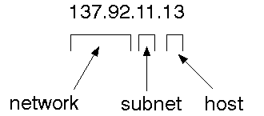

The 32 bit address is usually written as 4 integers separated by dots.

### Port addresses

A service exists on a host, and is identified by its port. This is a 16 bit number. To send a message to a server, you send it to the port for that service of the host that it is running on. This is not location transparency! Certain of these ports are "well known".

### Sockets

A socket is a data structure maintained by the system to handle network connections. A socket is created using the call socket. It returns an integer that is like a file descriptor. In fact, under Windows, this handle can be used with Read File and Write File functions.

#include <sys/types.h>

#include <sys/socket.h>

int socket(int family, int type, int protocol);

Here "family" will be AF_INET for IP communications, protocol will be zero, and type will depend on whether TCP or UDP is used. Two processes wishing to communicate over a network create a socket each. These are similar to two ends of a pipe - but the actual pipe does not yet exist.

**JFree Chart**

**J**FreeChart is a free 100% Java chart library that makes it easy for developers to display professional quality charts in their applications. JFreeChart's extensive feature set includes:

A consistent and well-documented API, supporting a wide range of chart types;

A flexible design that is easy to extend, and targets both server-side and client-side applications;

Support for many output types, including Swing components, image files (including PNG and JPEG), and vector graphics file formats (including PDF, EPS and SVG);

JFreeChart is "open source" or, more specifically, [free software](http://www.gnu.org/philosophy/free-sw.html). It is distributed under the terms of the [GNU Lesser General Public Licence](http://www.gnu.org/licenses/lgpl.html) (LGPL), which permits use in proprietary applications.

## Map Visualizations:

Charts showing values that relate to geographical areas. Some examples include: (a) population density in each state of the United States, (b) income per capita for each country in Europe, (c) life expectancy in each country of the world. The tasks in this project include:

Sourcing freely redistributable vector outlines for the countries of the world, states/provinces in particular countries (USA in particular, but also other areas);

Creating an appropriate dataset interface (plus default implementation), a rendered, and integrating this with the existing XYPlot class in JFreeChart;

Testing, documenting, testing some more, documenting some more.

## Time Series Chart Interactivity:

Implement a new (to JFreeChart) feature for interactive time series charts --- to display a separate control that shows a small version of ALL the time series data, with a sliding "view" rectangle that allows you to select the subset of the time series data to display in the main chart.

## Dashboards:

There is currently a lot of interest in dashboard displays. Create a flexible dashboard mechanism that supports a subset of JFreeChart chart types (dials, pies, thermometers, bars, and lines/time series) that can be delivered easily via both Java Web Start and an applet.

## Property Editors:

The property editor mechanism in JFreeChart only handles a small subset of the properties that can be set for charts. Extend (or reimplement) this mechanism to provide greater end-user control over the appearance of the charts.

# Tomcat 6.0 web server:

Tomcat is an open source web server developed by Apache Group. Apache Tomcat is the servlet container that is used in the official Reference Implementation for the Java Servlet and JavaServer Pages technologies. The Java Servlet and JavaServer Pages specifications are developed by Sun under the Java Community Process. Web Servers like Apache Tomcat support only web components while an application server supports web components as well as business components (BEAs Weblogic, is one of the popular application server).To develop a web application with jsp/servlet install any web server like JRun, Tomcat etc to run your application.

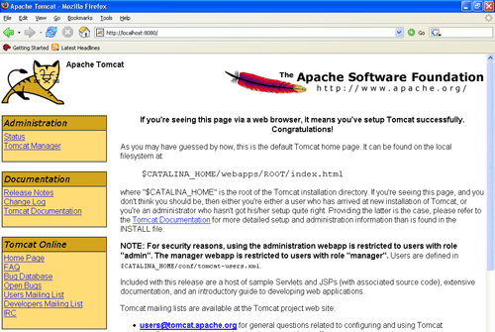

**SYSTEM DESIGN**

**Data Flow Diagram / Use Case Diagram / Flow Diagram**

The DFD is also called as bubble chart. It is a simple graphical formalism that can be used to represent a system in terms of the input data to the system, various processing carried out on these data, and the output data is generated by the system.

**FLOW DIAGRAM:**



**FLOWCHART DIAGRAM**

**DFD2:**



**COMPONENT:**



**C0MPONENTS**

**ACTIVITY DIAGRAM:**



**ACTIVITY DIAGRAM**

**CLASS DIAGRAM:**



**CLASS DIAGRAM**

**SEQUENCIAL DIAGRAM:**



**SEQUENCIAL DIAGRAM:**

**USE CASE DIAGRAM:**



**USE CASE DIAGRAM**

***INPUT DESIGN***

The input design is the link between the information system and the user. It comprises the developing specification and procedures for data preparation and those steps are necessary to put transaction data in to a usable form for processing can be achieved by inspecting the computer to read data from a written or printed document or it can occur by having people keying the data directly into the system. The design of input focuses on controlling the amount of input required, controlling the errors, avoiding delay, avoiding extra steps and keeping the process simple. The input is designed in such a way so that it provides security and ease of use with retaining the privacy. Input Design considered the following things:

* What data should be given as input?
* How the data should be arranged or coded?
* The dialog to guide the operating personnel in providing input.
* Methods for preparing input validations and steps to follow when error occur.

**OBJECTIVES**

1. Input Design is the process of converting a user-oriented description of the input into a computer-based system. This design is important to avoid errors in the data input process and show the correct direction to the management for getting correct information from the computerized system.

2. It is achieved by creating user-friendly screens for the data entry to handle large volume of data. The goal of designing input is to make data entry easier and to be free from errors. The data entry screen is designed in such a way that all the data manipulates can be performed. It also provides record viewing facilities.

3. When the data is entered it will check for its validity. Data can be entered with the help of screens. Appropriate messages are provided as when needed so that the user

will not be in maize of instant. Thus the objective of input design is to create an input layout that is easy to follow

**OUTPUT DESIGN**

A quality output is one, which meets the requirements of the end user and presents the information clearly. In any system results of processing are communicated to the users and to other system through outputs. In output design it is determined how the information is to be displaced for immediate need and also the hard copy output. It is the most important and direct source information to the user. Efficient and intelligent output design improves the system’s relationship to help user decision-making.

1. Designing computer output should proceed in an organized, well thought out manner; the right output must be developed while ensuring that each output element is designed so that people will find the system can use easily and effectively. When analysis design computer output, they should Identify the specific output that is needed to meet the requirements.

2.Select methods for presenting information.

3.Create document, report, or other formats that contain information produced by the system.

The output form of an information system should accomplish one or more of the following objectives.

* Convey information about past activities, current status or projections of the
* Future.
* Signal important events, opportunities, problems, or warnings.
* Trigger an action.
* Confirm an action.

**IMPLEMENTATION**

Implementation is the stage of the project when the theoretical design is turned out into a working system. Thus it can be considered to be a simple stage in achieving a successful new system and in giving the user, confidence that the e-workshop will work and be effective.

The implementation stage involves careful planning, investigation of the existing system and it’s constraints on implementation, designing of methods to him/her work very easy.

**MODULE DESCRIPTION**

In this online car service on local garages project four modules are there such as given below:

* User Login module
* Free listing module
* Setting module
* Garage module
* **User Login module**:

Here registered user can login to the website by entering his user id and password. New user can create new account by using registration form in this module. After login to this website there will be a garage search options.

* **Free Listing module**:

In this module garage owners can register their garage details and contact person detail briefly in free listing page of the website so they can develop their business. One of the main motive of this online car service on local garage is we love local business and we help small business to get more customer.

* **Settings module**:

This module is available for Administrator of the online car service on local garage webpage and he can maintain garages and employee details and registered customer details and query of the users in this module. The administrator has full right to access and modify this website.

* **Garage module**:

A mechanic or the garage owner manages customer’s vehicle details, spare parts etc and the website online car service on local garage will report the detail of how many customer arrived to their shop by browsing the website and this website will free service coupons to the lucky customer garage owner will be paid by website for that free coupons.

**HOME PAGE:**

<%@ page language="java" contentType="text/html; charset=ISO-8859-1"

pageEncoding="ISO-8859-1"%>

<!DOCTYPE html PUBLIC "-//W3C//DTD HTML 4.01 Transitional//EN" "http://www.w3.org/TR/html4/loose.dtd">

<html>

<head>

<meta http-equiv="Content-Type" content="text/html; charset=ISO-8859-1">

<title>E-WORKSHOP</title>

<style>

*

{

margin:0px;

padding:0px;

}

.container

{

height:1200px;

width:1400px;

background-color:white;

position:absolute;

background-image:url("pics/.jpg");

background-size:100% 100%;

}

.header

{

height:70px;

width:900px;

background-color:orange;

margin-left:50px;

margin-top:10px;

position:absolute;

padding:15px;

border-radius:20px;

border-color:black;

background-image:url("pics/download.png");

background-size:100% 100%;

}

.menu

{

height:40px;

width:900px;

background-color:orange;

margin-left:50px;

margin-top:120px;

position:absolute;

border-radius:20px;

background-image:;

}

.content

{

height:400px;

width:900px;

background-color:black;

margin-left:50px;

margin-top:180px;

position:absolute;

background-size:100% 100%;

border-radius:20px;

}

.div1

{

height:250px;

width:290px;

background-color:orange;

margin-left:50px;

margin-top:600px;

position:absolute;

border-radius:20px;

float:left;

}

.div2

{

height:250px;

width:290px;

background-color:orange;

margin-left:355px;

margin-top:600px;

position:absolute;

border-radius:20px;

float:left;

}

.div3

{

height:250px;

width:290px;

background-color:orange;

margin-left:660px;

margin-top:600px;

position:absolute;

border-radius:20px;

}

.taskbar

{

height:300px;

width:600px;

background-color:orange;

margin-left:315px;

margin-top:870px;

position:absolute;

border-radius:20px;

flaot:left;

}

.sub-taskbar

{

height:110px;

width:600px;

background-color:green;

margin-left:315px;

margin-top:1180px;

position:absolute;

border-radius:20px;

}

.div4

{

height:450px;

width:300px;

background-color:white;

margin-left:10px;

margin-top:870px;

position:absolute;

float:left;

}

ul li

{

display:inline-block;

margin-top:10px;

margin-left:70px;

font-color:black;

}

ul li a

{

color:black;

font-size:15px;

background-size:100% 100%;

}

ul li a:hover

{

color:black;

font-size:25px;

}

.dropdown-content

{

display:none;

position:absolute;

backgound-color:black;

min-width:160px;

box-shadow:0px 9px 16px 0px rgba(o,o,o,o.2)

}

.dropdown-content a

{

color:black;

padding:12px 16px;

text-decoration:none;

display:block;

text-align:left;

}

td

{

font-size:0px;

padding:5px;

align:right;

margin left:50px;

}

h2

{

padding:10px;

}

h3

{

padding:10px;

margin-top:0px

}

</style>

</head>

<body>

<div class="container">

<div class="header">

</div>

<div class="menu">

<div class="dropdown-content" id="mydropdown">

<a href="">NEW USER</a>

<a href="">EXISTING</a>

</div>

<ul style="list-style-type:bold;">

<li><a href="home.jsp">HOME</a></li>

<li><a href="LOGIN.jsp">USER LOGIN</a></li>

<li><a href="workshoplogin.jsp">FREE LISTING</a></li>

<li><a href="subscribe.jsp">HOT DEALS</a></li>

<li><a href="aboutus.jsp">ABOUT US</a></li>

</ul>

</div>

<div class="dropdown-content" id="mydropdown">

<a href="">NEW USER</a>

<a href="">EXISTING</a>

</div>

<div class="content">

<marquee>

<img style="width:900px;height:400px;" src="pics/1-AA-18678.jpg">

<img style="width:900px;height:400px;" src="pics/Customer-Service-Skills.jpg">

<img style="width:900px;height:400px;" src="pics/home1.jpg">

<img style="width:900px;height:400px;" src="pics/home2.jpg">

<img style="width:900px;height:400px;" src="pics/home3.jpg">

<img style="width:900px;height:400px;" src="pics/home4.jpg">

<img style="width:900px;height:400px;" src="pics/6787952-Repair-of-the-engine-A-hand-with-the-tool-Automobile-service--Stock-Photo.jpg">

<img style="width:900px;height:400px;" src="pics/los-talleres-del-mecnico-con-el-mecnico-de-sexo-masculino-debajo-del-vehculo-que-substituye-el-embrague-parte-en-el-garaje-30315026.jpg">

</marquee>

</div>

<div class="div1">

<h2 align="center">BIKE SERVICING</h2>

<BR>

<marquee behavior="slide" direction="up"><p align="justify"> We do complete bike servicing for our customers in best price our main punch is to easy to find workshops nearby you location if you register in our website we will display workshops and mechanic details so its easy recover your vechicle and we will followup your vechicle updates till its repaired. </p></marquee>

</div>

<div class="div2">

<h2 align="center">CAR SERVICING</h2>

<BR>

<marquee behavior="slide" direction="up"><p align="justify">We do complete car servicing for our customers in best price our main punch is to easy to find workshops nearby you location if you register in our website we will display workshops and mechanic details so its easy recover your vechicle and we will followup your vechicle updates till its repaired. </p></marquee>

</div>

<div class="div3">

<h2 align="center">VEHICLE INSURANCE</h2>

<BR>

<marquee behavior="slide" direction="up"><p align="justify">Drive safe and keep your vehicle safe as well, for this we offer vehicle insurance for our clients with minimal hassle. This leads to an easy car or bike insurance and easy renewal as well. </p></marquee>

</div>

<div class="div4">

<img style="width:300px;height:150px;" src="pics/a.png">

<img style="width:300px;height:150px;" src="pics/slide-autoservice.jpg">

<br>

<img style="width:300px;height:100px;" src="pics/green-flash-chrome-right.gif">

</div>

<div class="taskbar">

<h2 align="center">CONTACT</h2>

<h3><img alt="" src="pics/download (2).jpg" width="25" height="30" align="absmiddle" font-color="red">&nbsp&nbspE-WORKSHOP</h3>

<h3><img alt="" src="pics/images.png" width="25" height="30" align="absmiddle">NO:4,ANNAGARGEN,VELACHERY MAINROAD</h3>

<h3>VELACHERY,CHENNAI-600042</h3>

<h3>INDIA</h3>

<h3><img alt="" src="pics/images (3).jpg" width="25" height="30" align="absmiddle" background-color="yellow">Tel:044-26734587,mobile:8939044650</h3>

</div>

<div class="sub-taskbar">

<h2 align="left">SING UP FOR OUR NEWSLETTER</h2>

<form action="subscribe.jsp" method="post" >

<table align="right">

<tr >

<td></td>

<td align="right"><input type="text" name="emailid" ></td>

</tr>

</table>

<h3 align="left" >(stay updated with our news and offers)&nbsp&nbsp&nbsp&nbsp&nbsp&nbsp&nbsp&nbsp&nbsp&nbsp&nbsp&nbsp&nbsp&nbsp&nbsp&nbsp&nbsp&nbsp&nbsp&nbsp&nbsp&nbsp&nbsp&nbsp&nbsp&nbsp&nbsp&nbsp&nbsp&nbsp&nbsp&nbsp&nbsp&nbsp&nbsp&nbsp&nbsp&nbsp&nbsp&nbsp&nbsp&nbsp&nbsp&nbsp&nbsp&nbsp&nbsp&nbsp&nbsp&nbsp&nbsp&nbsp&nbsp&nbsp&nbsp&nbsp&nbsp&nbsp&nbsp&nbsp&nbsp&nbsp&nbsp&nbsp&nbsp&nbsp&nbsp&nbsp&nbsp&nbsp&nbsp&nbsp&nbsp&nbsp&nbsp&nbsp&nbsp&nbsp&nbsp&nbsp&nbsp&nbsp&nbsp&nbsp&nbsp&nbsp&nbsp

<input type="submit" name="submit" value="SUBSCRIBE" style="background-color:orange;"></h3>

</form>

</div>

</div>

</body>

</html

**LOGIN PAGE:**

**<%@ page language="java" contentType="text/html; charset=ISO-8859-1"**

**pageEncoding="ISO-8859-1"%>**

**<!DOCTYPE html PUBLIC "-//W3C//DTD HTML 4.01 Transitional//EN" "http://www.w3.org/TR/html4/loose.dtd">**

**<html>**

**<head>**

**<meta http-equiv="Content-Type" content="text/html; charset=ISO-8859-1">**

**<title>LOGIN</title>**

**<style>**

**\***

**{**

**margin:0px;**

**padding:0px;**

**}**

**.container**

**{**

**height:700px;**

**width:1000px;**

**background-color:black;**

**position:absolute;**

**background-image:url("pics/.jpg");**

**background-size:100% 100%;**

**}**

**.header**

**{**

**height:70px;**

**width:500px;**

**background-color:red;**

**margin-left:230px;**

**margin-top:0px;**

**position:absolute;**

**padding:15px;**

**border-radius:0px;**

**background-image:url("pics/e-workshop1.png");**

**background-size:100% 100%;**

**}**

**.menu**

**{**

**height:70px;**

**width:500px;**

**background-color:black;**

**margin-left:230px;**

**margin-top:120px;**

**position:absolute;**

**padding:15px;**

**border-radius:0px;**

**background-image:url("pics/login-hd.png");**

**background-size:100% 100%;**

**}**

**.menubar**

**{**

**height:40px;**

**width:370px;**

**background-color:black;**

**margin-left:300px;**

**margin-top:240px;**

**position:absolute;**

**padding:15px;**

**border-radius:0px;**

**background-image:url("pics/.jpg");**

**background-size:100% 100%;**

**}**

**.div1**

**{**

**height:250px;**

**width:150px;**

**background-color:black;**

**margin-left:45px;**

**margin-top:320px;**

**float:left;**

**}**

**.login**

**{**

**height:250px;**

**width:400px;**

**background-color:yellow;**

**background-image:url("pics/download (7).jpg");**

**margin-left:300px;**

**margin-top:320px;**

**position:absolute;**

**float:left;**

**}**

**.div2**

**{**

**height:250px;**

**width:150px;**

**background-color:black;**

**margin-left:780px;**

**margin-top:320px;**

**}**

**ul li**

**{**

**display:inline-block;**

**margin-top:10px;**

**margin-left:70px;**

***font-color:black;***

***}***

***ul li a***

***{***

***color:black;***

***font-size:15px;***

***background-size:100% 100%;***

***}***

***ul li a:hover***

***{***

***color:black;***

***font-size:15px;***

***}***

***td***

***{***

***font-size:20px;***

***padding:15px;***

***margin:10px;***

***}***

***</style>***

***</head>***

***<script type= "text/javascript">***

***function validation()***

***{***

***var a = document.form.username.value;***

***if(a=="")***

***{***

***alert("please enter the username")***

***document.form.username.focus;***

***return false;***

***}***

***var b = document.form.password.value;***

***if(b=="")***

***{***

***alert("please enter the password");***

***document.form.password.focus();***

***return false;***

***}***

***}***

***</script>***

***<body>***

***<div class="container">***

***<div class="header">***

***</div>***

***<div class="menu">***

***</div>***

***<div class= "menubar">***

***<ul>***

***<li><a href="home.jsp"><h3><font color="white" size="4">HOME</font></h3></a></li>***

***<li><a href="register.jsp"><h3><font color="white" size="4">REGISTER NOW</font></h3></a></li>***

***</ul>***

***</div>***

***<div class="div1">***

***<marquee direction="up" height=250px;>s***

***<img style="width:150px;height:250px;direction:up;" src="pics/BK5yN6E.jpg">***

***<img style="width:150px;height:250px;direction:up;" src="pics/Bajaj-destiny-Ahead1.jpg">***

***<img style="width:150px;height:250px;direction:up;" src="pics/hero_moto_corp.png">***

***<img style="width:150px;height:250px;direction:up;" src="pics/Honda-logo.jpg">***

***<img style="width:150px;height:250px;direction:up;" src="pics/Dukati_non_obsolete_Logo.png">***

***<img style="width:150px;height:250px;direction:up;" src="pics/motogp-logo.png">***

***</marquee>***

***</div>***

***<div class="login">***

***<form action="LOGINDB.jsp" method="post" name="form" onsubmit="return validation()">***

***<h1 align="center" >USER LOGIN</h1>***

***<table>***

***<tr>***

***<td>USER-NAME:</td>***

***<td><input type="text" name="username" ></td>***

***</tr>***

***<tr>***

***<td>PASSWORD:</td>***

***<td><input type="password" name="password"></td>***

***</tr>***

***<tr>***

***<td></td>***

***<td><input type="submit" name="register" value="LOGIN"></td>***

***</tr>***

***</table>***

***</form>***

***</div>***

***<div class="div2"***

*<marquee behavior="scroll" direction="up" height=250px;>*

*<img style="width:150px;height:250px;direction:up;" src="pics/BMW-Company-Logo-Image.gif">*

*<img style="width:150px;height:250px;direction:up;" src="pics/Chevrolet-Logo-Small.jpg">*

*<img style="width:150px;height:250px;direction:up;" src="pics/ford.png">*

***<****imgstyle="width:150px;height:250px;direction:up;"src="pics/1024px-Mahindra_&_Mahindra_Logo.svg.png">*

*<img style="width:150px;height:250px;direction:up;" src="pics/200991190125.jpg">*

*<img style="width:150px;height:250px;direction:up;" src="pics/jaguar-logo.png">*

*</marquee>*

*</div>*

*</div>*

*</body>*

*</html>*

***FREELISTING:***

***<%@ page language="java" contentType="text/html; charset=ISO-8859-1"***

***pageEncoding="ISO-8859-1"%>***

***<!DOCTYPE html PUBLIC "-//W3C//DTD HTML 4.01 Transitional//EN" "http://www.w3.org/TR/html4/loose.dtd">***

***<html>***

***<head>***

***<meta http-equiv="Content-Type" content="text/html; charset=ISO-8859-1">***

***<title>WORKSHOP-REGISTRATION</title>***

***<style>***

***\****

***{***

***margin:0px;***

***padding:0px;***

***}***

***.container***

***{***

***height:1120px;***

***width:1020px;***

***background-color:white;***

***position:absolute;***

***background-image:url("pics/.jpg");***

***background-size:100% 100%;***

***}***

***.header***

***{***

***height:80px;***

***width:800px;***

***background-color:;***

***margin-left:80px;***

***margin-top:0px;***

***padding:15px;***

***border-radius:20px;***

***background-image:url("pics/e-workshop-2 (1).png");***

***background-size:100% 100%;***

***}***

***.div1***

***{***

***height:110px;***

***width:170px;***

***background-color:orange;***

***background-image:url("pics/FREE-business-listings1 (1).gif");***

***margin-left:0px;***

***margin-top:0px;***

***position:absolute;***

***background-size:100% 100%;***

***float:left;***

***}***

***.menu***

***{***

***height:110px;***

***width:650px;***

***background-color:black;***

***margin-left:170px;***

***margin-top:0px;***

***position:absolute;***

***background-image:url("pics/Dubai-Company-Listing-Dubai-UAE-1.png");***

***background-size:100% 100%;***

***float:left;***

***}***

***.div2***

***{***

***height:110px;***

***width:190px;***

***background-color:orange;***

***background-image:url("pics/FREE-business-listings1 (1).gif");***

***margin-left:820px;***

***margin-top:0px;***

***position:absolute;***

***background-size:100% 100%;***

***float:left;***

***}***

***.content***

***{***

***height:900px;***

***width:650px;***

***background-color:orange;***

***background-image:url("pics/.jpg");***

***background-size:100% 100%;***

***margin-left:170px;***

***margin-top:110px;***

***position:absolute;***

***float:left;***

***}***

***ul li***

***{***

***display:inline-block;***

***margin-top:10px;***

***margin-left:40px;***

***font-color:gold;***

***}***

***ul li a***

***{***

***color:black;***

***font-size:20px;***

***background-size:100% 100%;***

***}***

***ul li a:hover***

***{***

***color:red;***

***font-size:25px;***

***}***

***td***

***{***

***font-size:15px;***

***padding:15px;***

***margin:10px;***

***}***

***h1***

***{***

***padding:15px;***

***}***

***</style>***

***</head>***

***<script type= "text/javascript">***

***function validation()***

***{***

***var a1 = document.form.id.value;***

***if(a1=="")***

***{***

***alert("please enter the id")***

***document.form.id.focus;***

***return false;***

***}***

***var a = document.form.companyname.value;***

***if(a=="")***

***{***

***alert("please enter the companyname")***

***document.form.companyname.focus;***

***return false;***

***}***

***var b = document.form.place.value;***

***if(b=="")***

***{***

***alert("please enter the place");***

***document.form.place.focus();***

***return false;***

***}***

***var c = document.form.address.value;***

***if(c=="")***

***{***

***alert("please enter the address");***

***document.form.address.focus();***

***return false;***

***}***

***var d = document.form.landmark.value;***

***if(d=="")***

***{***

***alert("please enter the landmark");***

***document.form.landmark.focus();***

***return false;***

***}***

***var e = document.form.state.value;***

***if(e=="")***

***{***

***alert("please enter the state");***

***document.form.state.focus();***

***return false;***

***}***

***var f = document.form.country.value;***

***if(f=="")***

***{***

***alert("please enter the country");***

***document.form.country.focus();***

***return false;***

***}***

***var g = document.form.contactname.value;***

***if(g=="")***

***{***

***alert("please enter the contactname");***

***document.form.contactname.focus();***

***return false;***

***}***

***var h= document.form.designation.value;***

***if(h=="")***

***{***

***alert("please enter the designation");***

***document.form.designation.focus();***

***return false;***

***}***

***}***

***</script>***

***<body>***

***<div class="container">***

***<div class="header">***

***</div>***

***<div class="div1">***

***</div>***

***<div class="menu">***

***</div>***

***<div class="div2">***

***</div>***

***<div class="content">***

***<form action="freelistingdb.jsp" method="post" name="form" onsubmit="return validation()">***

***<h1 align="center" ><font color="white" >LOCATION INFORMATION</font></h1>***

***<table>***

***<tr>***

***<td><h3>ID:</h3> </td>***

***<td><input type="text" name="id"></td>***

***</tr>***

***<tr>***

***<td><h3>COMPANY NAME:</h3></td>***

***<td><input type="text" name="companyname"></td>***

***</tr>***

***<tr>***

***<td><h3>PLACE:</h3></td>***

***<td><input type="text" name="place"></td>***

***</tr>***

***<tr>***

***<td><h3>ADDRESS:</h3></td>***

***<td><input type="text" name="address"></td>***

***</tr>***

***<tr>***

***<tr>***

***<td><h3>LAND MARK:</h3></td>***

***<td><input type="text" name="landmark"></td>***

***</tr>***

***<tr>***

***<td><h3>MODE OF TRANSPORT:</h3></td>***

***<td><select name="modeofvehicle">***

***<option value="bike">BIKE</option>***

***<option value="car">CAR</option>***

***<option value="both">both</option>***

***</select></td>***

***</tr>***

***<tr>***

***<td><h3>STATE:</h3></td>***

***<td><input type="text" name="state"></td>***

***</tr>***

***<tr>***

***<td><h3>COUNTRY:</h3></td>***

***<td><input type="text" name="country"></td>***

***</tr>***

***</table>***

***<h1 align="center"><font color="white" >CONTACT INFORMATION</font></h1>***

***<table>***

***<tr>***

***<td><h3>CONTACT PERSON:</h3></td>***

***<td><input type="text" name="contactperson"></td>***

***</tr>***

***<tr>***

***<tr>***

***<td><h3>DESIGNATION:</h3></td>***

***<td><input type="text" name="designation"></td>***

***</tr>***

***<tr>***

***<tr>***

***<td><h3>LANDLINE NO:</h3></td>***

***<td><input type="text" name="landlineno"></td>***

***</tr>***

***<tr>***

***<td><h3>MOBILE NO:</h3></td>***

***<td><input type="text" name="mobileno"></td>***

***</tr>***

***<tr>***

***<td><h3>EMAIL-ID:</h3></td>***

***<td><input type="text" name="emailid"></td>***

***</tr>***

***<tr>***

***<td></td>***

***<td><input type="submit" name="login" value="SAVE&CONTINUE"></td>***

***</tr>***

***</table>***

***</form>***

***</div>***

***</div>***

***</body>***

***</html>***

***SYSTEM TESTING***

The purpose of testing is to discover errors. Testing is the process of trying to discover every conceivable fault or weakness in a work product. It provides a way to check the functionality of components, sub assemblies, assemblies and/or a finished product It is the process of exercising software with the intent of ensuring that the Software system meets its requirements and user expectations and does not fail in an unacceptable manner. There are various types of test. Each test type addresses a specific testing requirement.

**TYPES OF TESTS**

**Unit testing**

Unit testing involves the design of test cases that validate that the internal program logic is functioning properly, and that program inputs produce valid outputs. All decision branches and internal code flow should be validated. It is the testing of individual software units of the application .it is done after the completion of an individual unit before integration. This is a structural testing, that relies on knowledge of its construction and is invasive. Unit tests perform basic tests at component level and test a specific business process, application, and/or system configuration. Unit tests ensure that each unique path of a business process performs accurately to the documented specifications and contains clearly defined inputs and expected results.

Integration testing

Integration tests are designed to test integrated software components to determine if they actually run as one program. Testing is event driven and is more concerned with the basic outcome of screens or fields. Integration tests demonstrate that although the components were individually satisfaction, as shown by successfully unit testing, the combination of components is correct and consistent. Integration testing is specifically aimed at exposing the problems that arise from the combination of components

**Functional test**

Functional tests provide systematic demonstrations that functions tested are available as specified by the business and technical requirements, system documentation, and user manuals.

Functional testing is centered on the following items:

Valid Input : identified classes of valid input must be accepted.

Invalid Input : identified classes of invalid input must be rejected.

Functions : identified functions must be exercised.

Output : identified classes of application outputs must be exercised.

Systems/Procedures : interfacing systems or procedures must be invoked.

Organization and preparation of functional tests is focused on requirements, key functions, or special test cases. In addition, systematic coverage pertaining to identify Business process flows; data fields, predefined processes, and successive processes must be considered for testing. Before functional testing is complete, additional tests are identified and the effective value of current tests is determined.

**RESULT AND SNAPSHOTS**

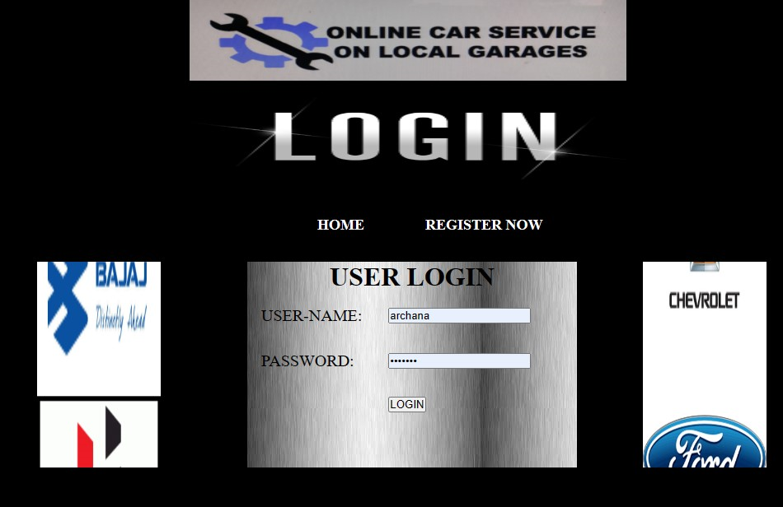

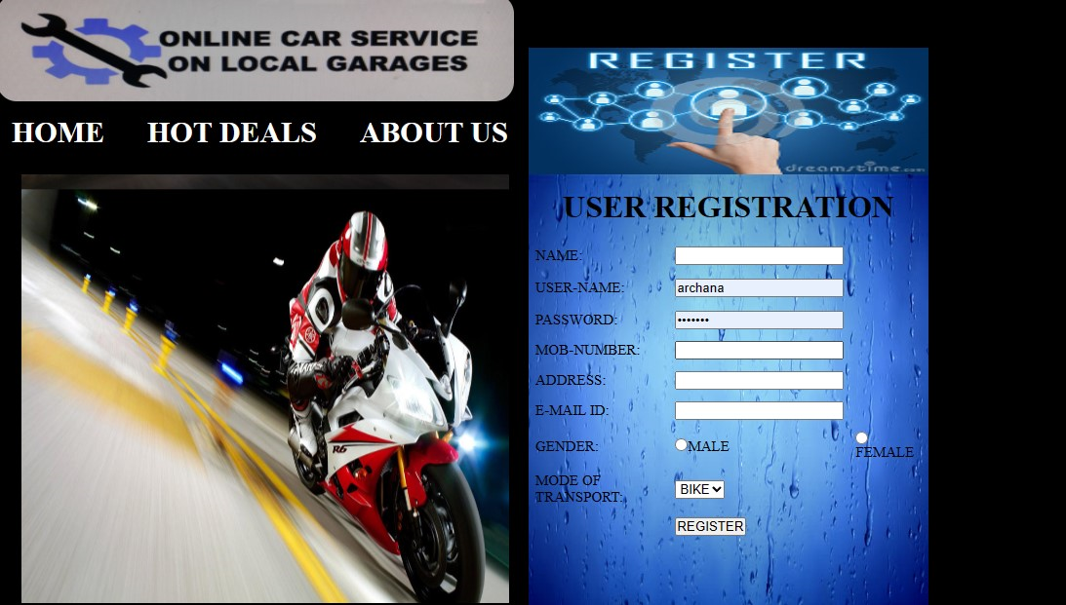

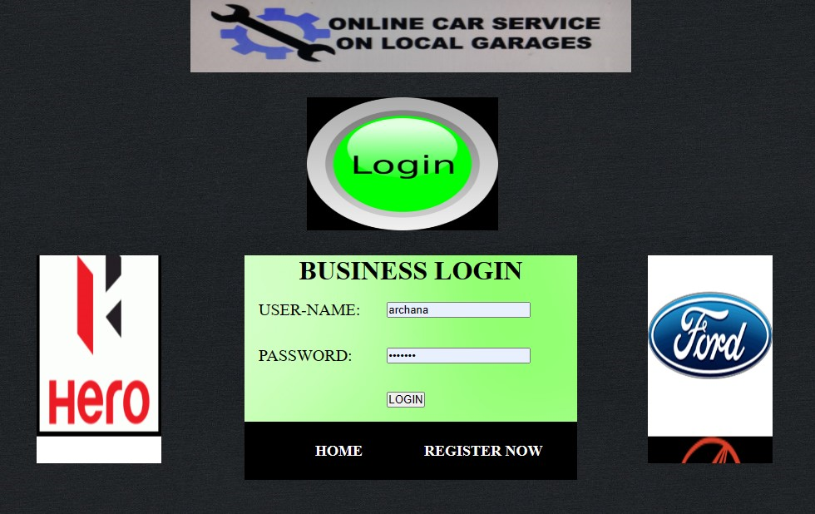

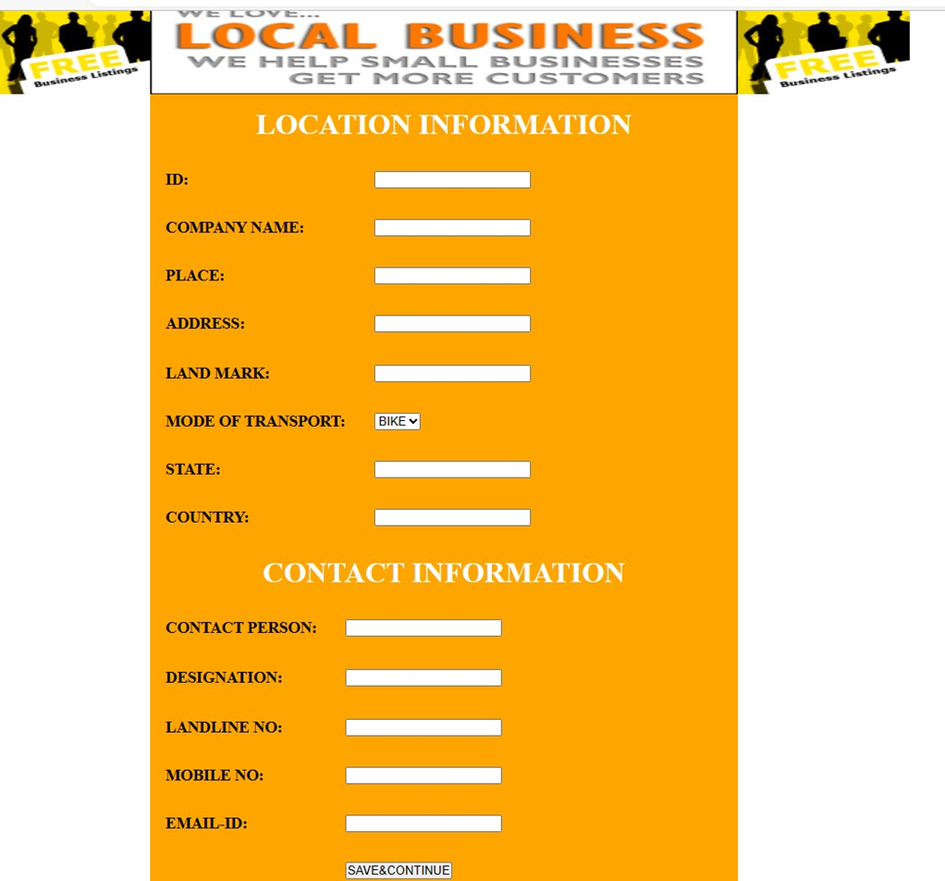

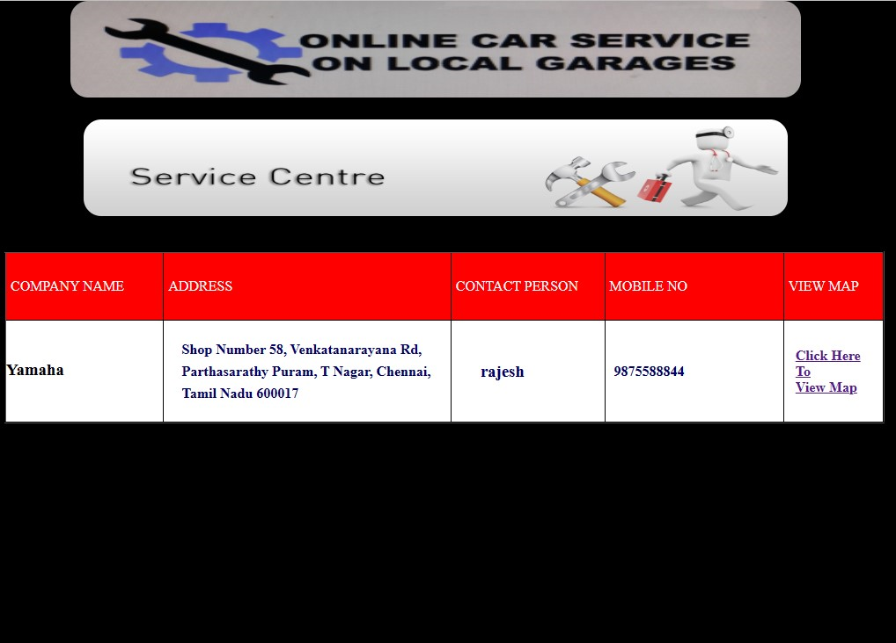

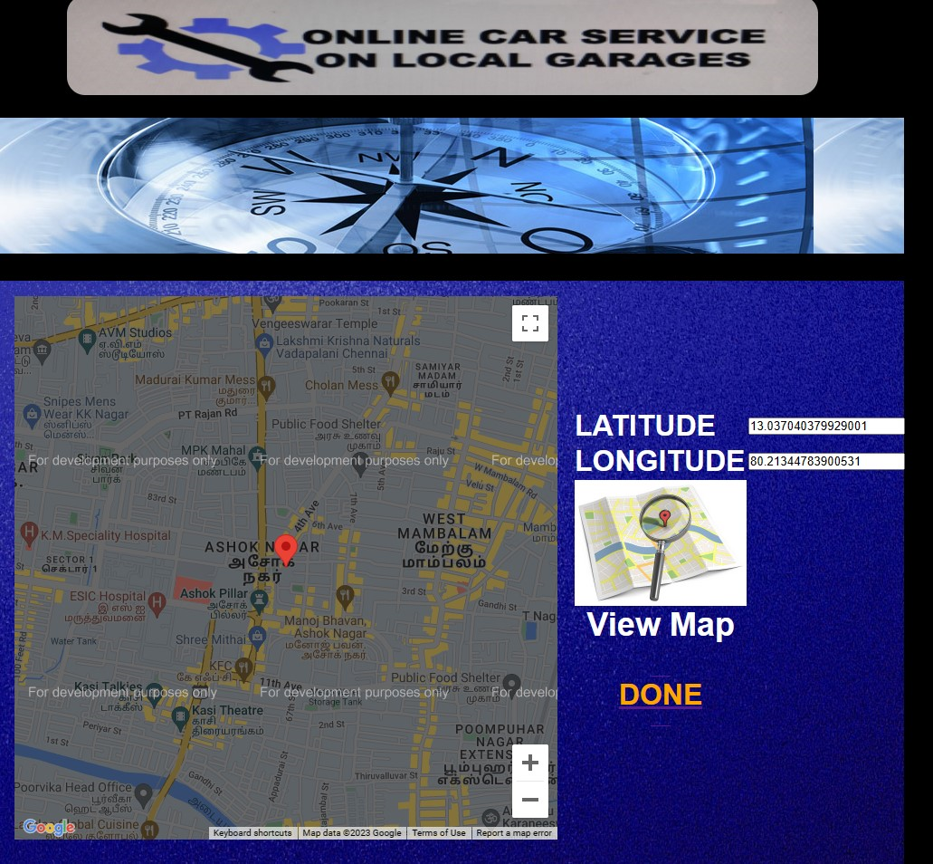

***CONCLUSION***

The conclusion in proposing system online car service on local garages it should be user-friendly and satisfies the user. Admin should play the vital role he should maintain the information about the garages locations and the mechanic information and user information. The administrator has full right to access and modify this website.

The web application developed here promises to make the life of a vehicle owner that much easier, as even in the probability of a car service the vehicle owner is assured of the fact that he has a solution to the problem within a few steps of entering details in his smart phone and save himself from a major setback in such an undesirable situation.

The package was designed in such a way that future modifications can be done easily. The following conclusions can be deduced from the development of the project.

• Automation of the entire system improves the efficiency

• It provides a friendly graphical user interface which proves to be better when compared to the existing system.

• It gives appropriate access to the authorized users depending on their permissions.

•It effectively overcomes the delay in communications

• Updating of information becomes so easier.

• System security, data security and reliability are the striking features.

**BIBLIOGRAPHY**

• W3 Schools PHP.

• [WWW.phpmysql.com](http://WWW.phpmysql.com).

• PHP - Wikipedia.

• Developer.mozilla.org.

• [www.scalar.com](http://www.scalar.com).

• geeksforgeeks.com

• blog.hubspot.com.

• [www.tutorialrepublic.com](http://www.tutorialrepublic.com).

• [www.codeacedemy.com](http://www.codeacedemy.com).

• www.freecodecamo.co